--CREATE TABLE Employees (

-- EmployeeID INT PRIMARY KEY ,

-- FirstName VARCHAR(50),

-- LastName VARCHAR(50),

-- Gender VARCHAR(10),

-- StartDate DATE,

-- Years INT,

-- Department VARCHAR(50),

-- Country VARCHAR(50),

-- Center VARCHAR(50),

-- MonthlySalary DECIMAL(10, 2),

-- AnnualSalary DECIMAL(12, 2),

-- JobRate INT,

-- SickLeaves INT,

-- UnpaidLeaves INT,

-- OvertimeHours INT

--);

-------------------1. Average Employee Tenure----------

SELECT

AVG(Years) AS AverageTenure

FROM

Employees;

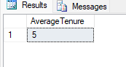

----------2. Department-wise Performance Ratings----------

SELECT

Department,

AVG(JobRate) AS AveragePerformanceRating

FROM

Employees

GROUP BY

Department

ORDER BY

AveragePerformanceRating DESC;

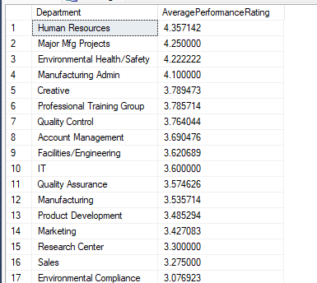

---------3. Employee Attrition Rate by Department----------

SELECT

Department,

COUNT(EmployeeID) AS TotalEmployees,

SUM(CASE WHEN Years < 5 THEN 1 ELSE 0 END) AS AttritionCount,

(SUM(CASE WHEN Years < 5 THEN 1 ELSE 0 END) / COUNT(EmployeeID)) * 100 AS AttritionRate

FROM

Employees

GROUP BY

Department

ORDER BY

AttritionRate DESC;

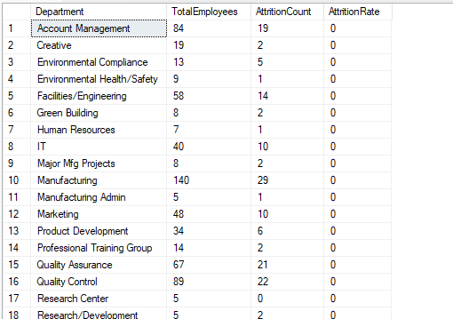

----------4. Employee Sick Leave Analysis------------

SELECT

Department,

AVG(SickLeaves) AS AvgSickLeaves

FROM

Employees

GROUP BY

Department

ORDER BY

AvgSickLeaves DESC;

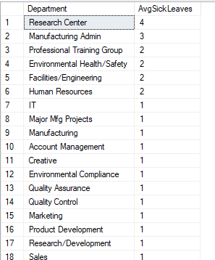

---------------5. Overtime Hours Analysis-----------

SELECT

FirstName,

LastName,

Department,

OvertimeHours,

JobRate

FROM

Employees

ORDER BY

OvertimeHours DESC

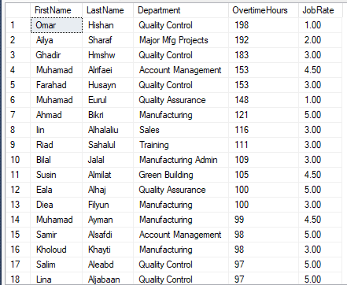

-------------6. Performance and Salary Correlation---------

SELECT

AVG(JobRate) AS AvgPerformance,

AVG(MonthlySalary) AS AvgMonthlySalary,

AVG(AnnualSalary) AS AvgAnnualSalary

FROM

Employees;

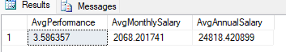

--------------7. Employees with Unpaid Leaves Above Average--------

WITH AvgUnpaidLeaves AS (

SELECT AVG(UnpaidLeaves) AS avg_unpaid FROM Employees

)

SELECT

FirstName,

LastName,

UnpaidLeaves

FROM

Employees, AvgUnpaidLeaves

WHERE

UnpaidLeaves > avg_unpaid;

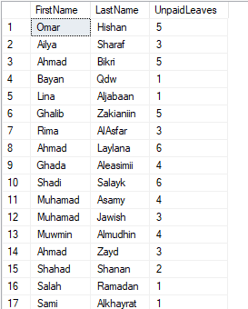

------------8. Department with the Most Overtime Hours----------

SELECT

Department,

SUM(OvertimeHours) AS TotalOvertime

FROM

Employees

GROUP BY

Department

ORDER BY

TotalOvertime DESC

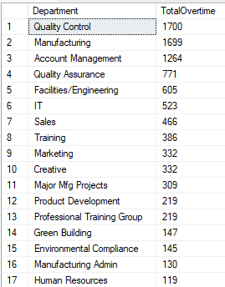

------------9. Highest Paid Employees by Department------------

SELECT

E.Department,

E.FirstName,

E.LastName,

E.MonthlySalary

FROM

Employees E

JOIN (

SELECT

Department,

MAX(MonthlySalary) AS MaxSalary

FROM

Employees

GROUP BY

Department

) AS MaxSalaries

ON E.Department = MaxSalaries.Department

AND E.MonthlySalary = MaxSalaries.MaxSalary

ORDER BY

E.Department;

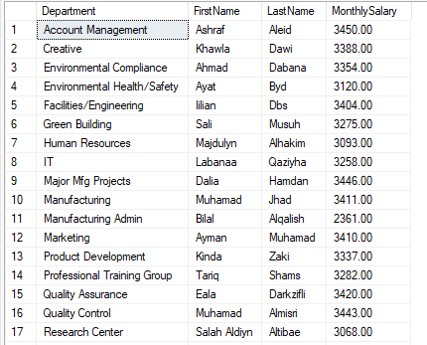

----10. Performance Review Distribution Across Departments----

SELECT

Department,

JobRate,

COUNT(*) AS CountOfEmployees

FROM

Employees

GROUP BY

Department, JobRate

ORDER BY

Department, JobRate;

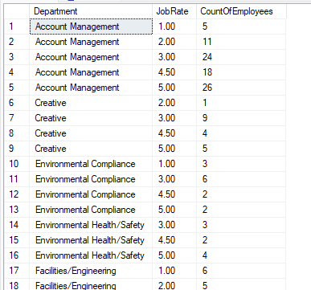

---------Fast Query Using a JOIN with Aggregates (Optimized for Performance)----------

SELECT

E.Department,

E.FirstName,

E.LastName,

E.MonthlySalary

FROM

Employees E

JOIN (

SELECT

Department,

MAX(MonthlySalary) AS MaxSalary

FROM

Employees

GROUP BY

Department

) AS MaxSalaries

ON E.Department = MaxSalaries.Department

AND E.MonthlySalary = MaxSalaries.MaxSalary

ORDER BY

E.Department;

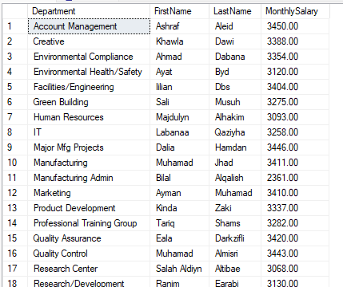

-----Query Using HAVING (Takes More Time)--------

SELECT

Department,

FirstName,

LastName,

MonthlySalary

FROM

Employees E1

GROUP BY

Department,

FirstName,

LastName,

MonthlySalary

HAVING

MonthlySalary = (

SELECT

MAX(MonthlySalary)

FROM

Employees E2

WHERE

E2.Department = E1.Department

)

ORDER BY

Department;

